**Group: 01**

Use Case: Booking any service

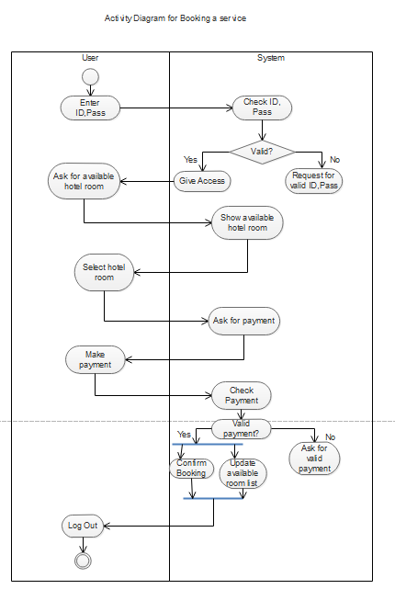

Use Case: Get information

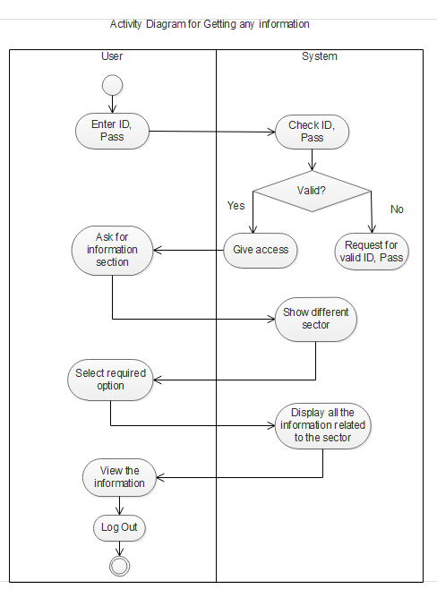

Use Case: Get suggestion

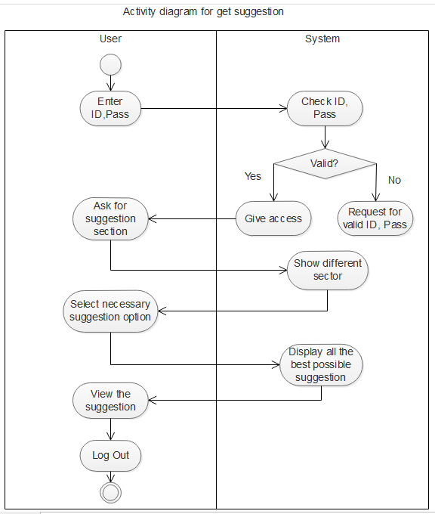

|  |  |
| --- | --- |
| Class name: User | |
| Sub Class: | |
| Super Class: | |
| Responsibilities | Collaborators |
| 1. Sign up, Sign in | 1. Customer 1 |
| 1. Get information | 2. Customer 2, etc. |
| 1. Booking any services |  |
| 1. Get suggestion |  |
|  |  |

|  |  |
| --- | --- |
| Class name: Admin | |
| Sub Class: | |
| Super Class: | |
| Responsibilities | Collaborators |
| 1. Verify user | 1. Booking admin |
| 1. Manage booking confirmation | 2. Verification admin |
|  |  |

|  |  |
| --- | --- |
| Class name: System | |
| Sub Class: | |
| Super Class: | |
| Responsibilities | Collaborators |
| 1. Show available booking option | 1. Booking system |
| 1. Check payment validity | 2. Payment system. |
| 1. Show suitable suggestion | 3 Suggestion system |
|  |  |